### **Plugging into the Future: An Exploration of Electricity Consumption Patterns**

1.INTRODUCTION:

India’s power consumption logged a double-digit year-on-year growth of nearly 13 per cent to 126.16 billion units in January 2023, according to government data. The robust growth of power consumption indicates sustained momentum of economic activities in January.  
Experts earlier said the power consumption and demand would increase in January due to the use of heating appliances, especially in the northern parts of the country, and a further improvement in economic activities. In January 2022, power consumption stood at 111.80 billion units (BU), higher than the 109.76 BU in the same month of 2021, the data showed.  
Electricity consumption in January 2020 stood at 105.15 BU. The peak power demand met, which is the highest supply in a day, rose to 210.61 gigawatt (GW) in January 2023.The peak power supply stood at 192.18 GW in January 2022 and 189.39 GW in January 2021.The peak power demand met was 170.97 GW in the pre-pandemic January 2020.

1.1 OVERVIEW:

The dataset is exhaustive in its demonstration of energy consumption state wise.  
Analysing Electricity Consumption in India from Jan 2019 till 5th December 2020. This dataset contains a record of electricity consumption in each state of India, here we are going to analyses State wise, Region wise and Overall Electricity consumption in India.

1.2 PURPOSE:

Annual electricity consumption per capita serves as an important measure of a country's electric power development. Generally speaking, electricity consumption grows faster when the industrialization process develops quickly and goes down rapidly when industrialization is completed or near completion.

In the Stated Policies Scenario, global electricity demand grows at 2.1% per year to 2040, twice the rate of primary energy demand. This raises electricity's share in total final energy consumption from 19% in 2018 to 24% in 2040. Electricity demand growth is set to be particularly strong in developing economies.From this project we can able to understand the present state of electricity consumption and we here came across to known about the different states,regions and total consumption of electricity.

2.PROBLEM DEFINITION AND DESIGN THINKING:

2.1 EMPATHY MAP:

An empathy map is a collaborative visualization used to articulate what we know about a particular type of user. It externalizes knowledge about users in order to 1) create a shared understanding of user needs, and 2) aid in decision making.

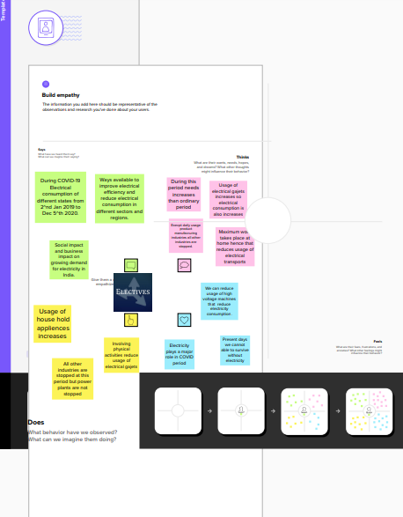

2.2 BRAINSTROM MAP:

A mind map is a visualization technique and brainstorming tool which allows you to explore a central idea, and all of its related topics, in a non-linear way. When brainstorming, or attempting to see a particular topic from all angles, linear tools — like lists — aren't always the best solution.

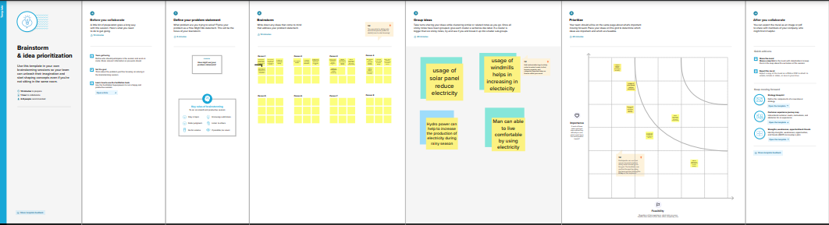

3.RESULT:

The output we gained on the topic of **Plugging into the Future: An Exploration of Electricity Consumption Patterns** are given below in the form of screenshot.

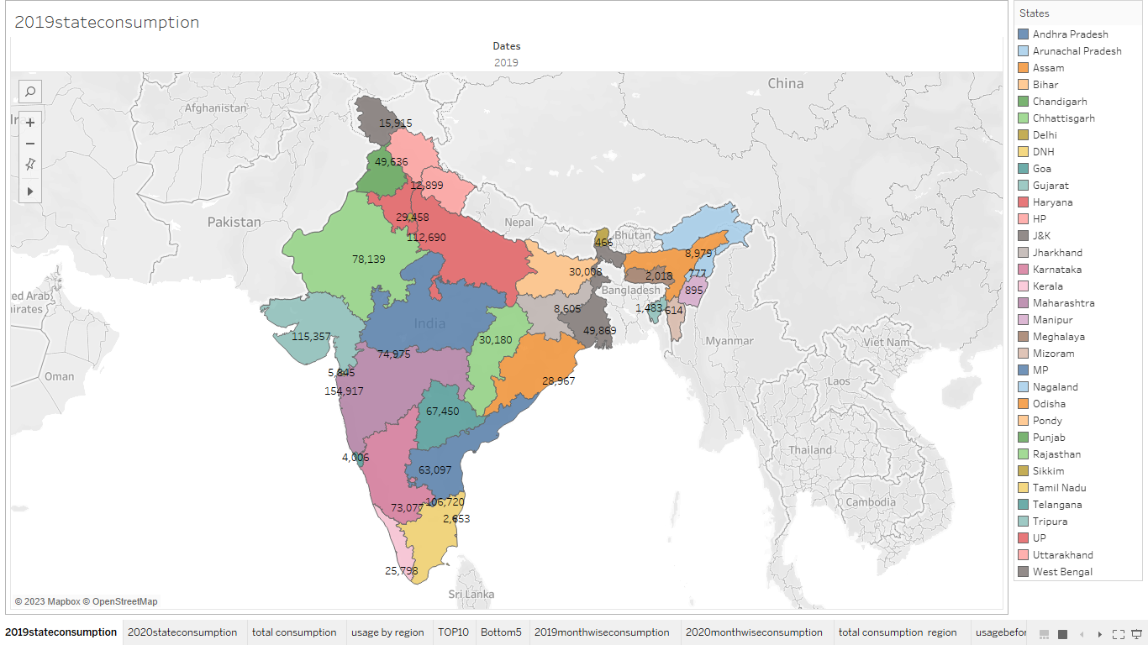

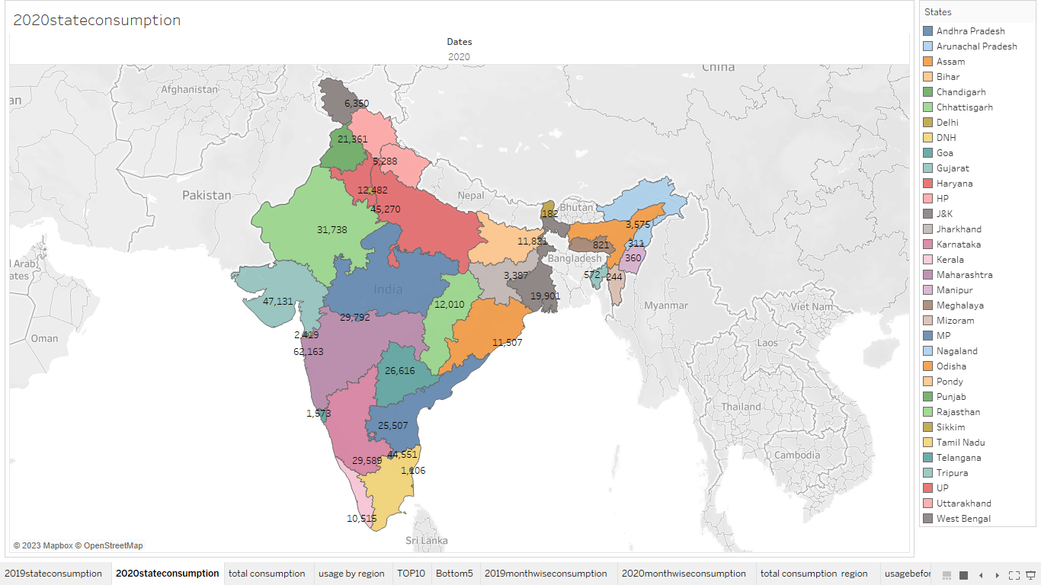

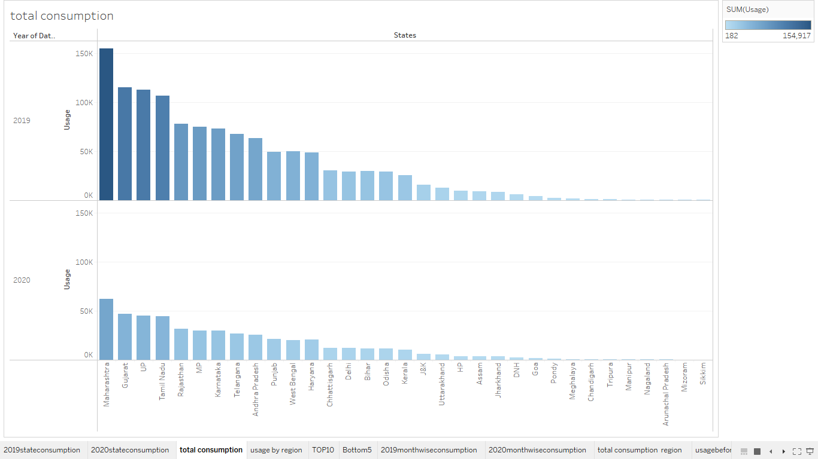

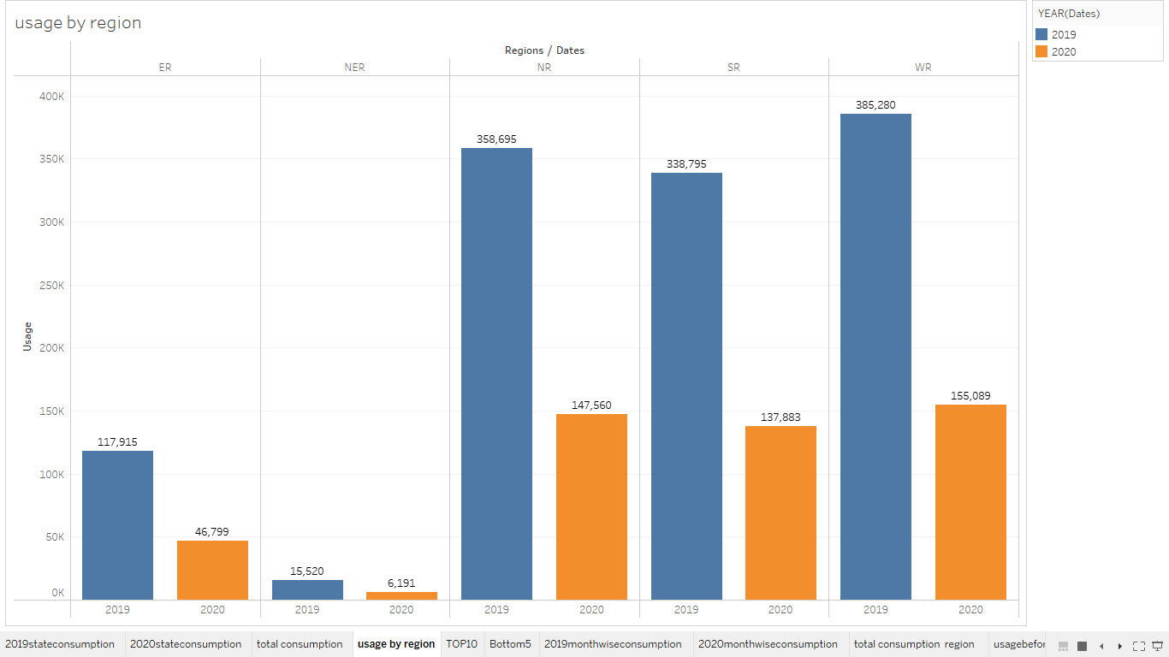

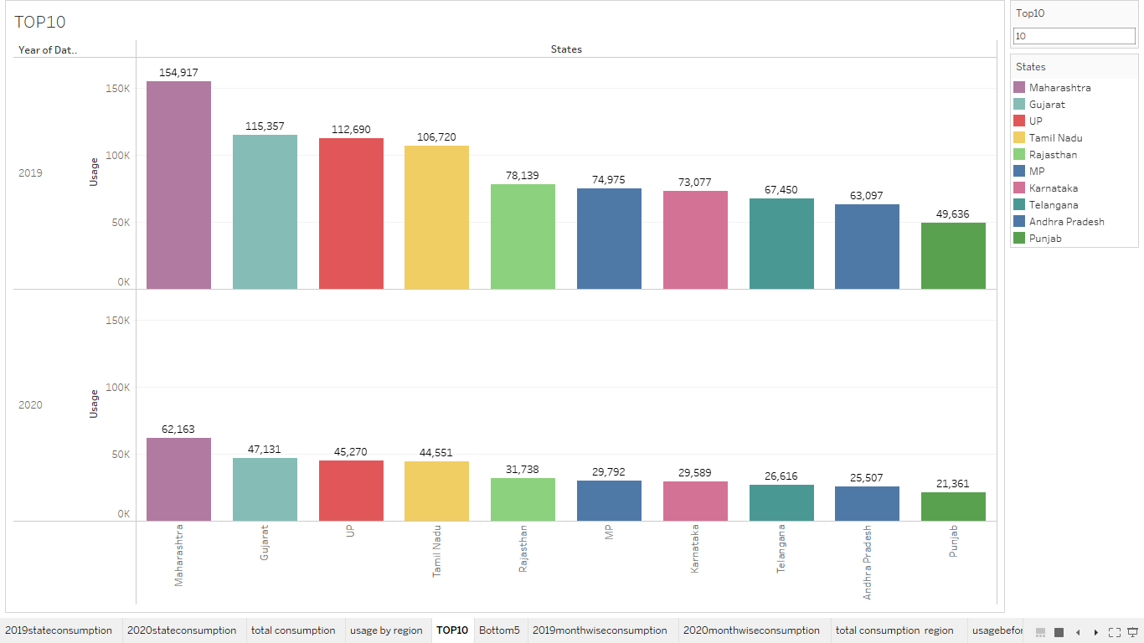

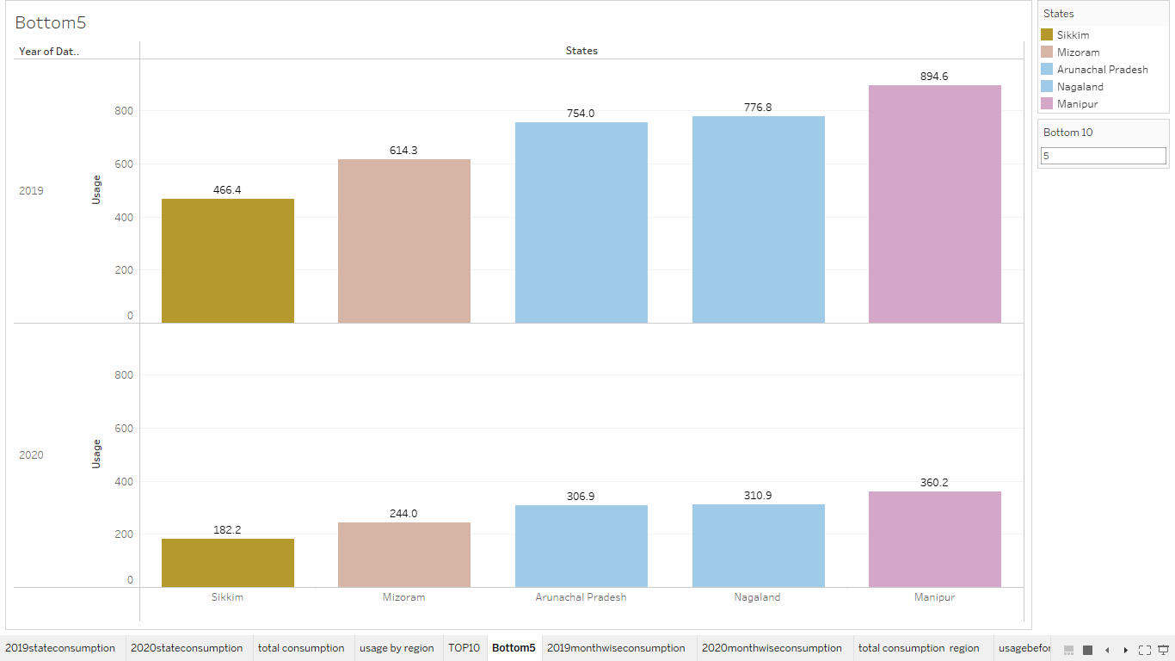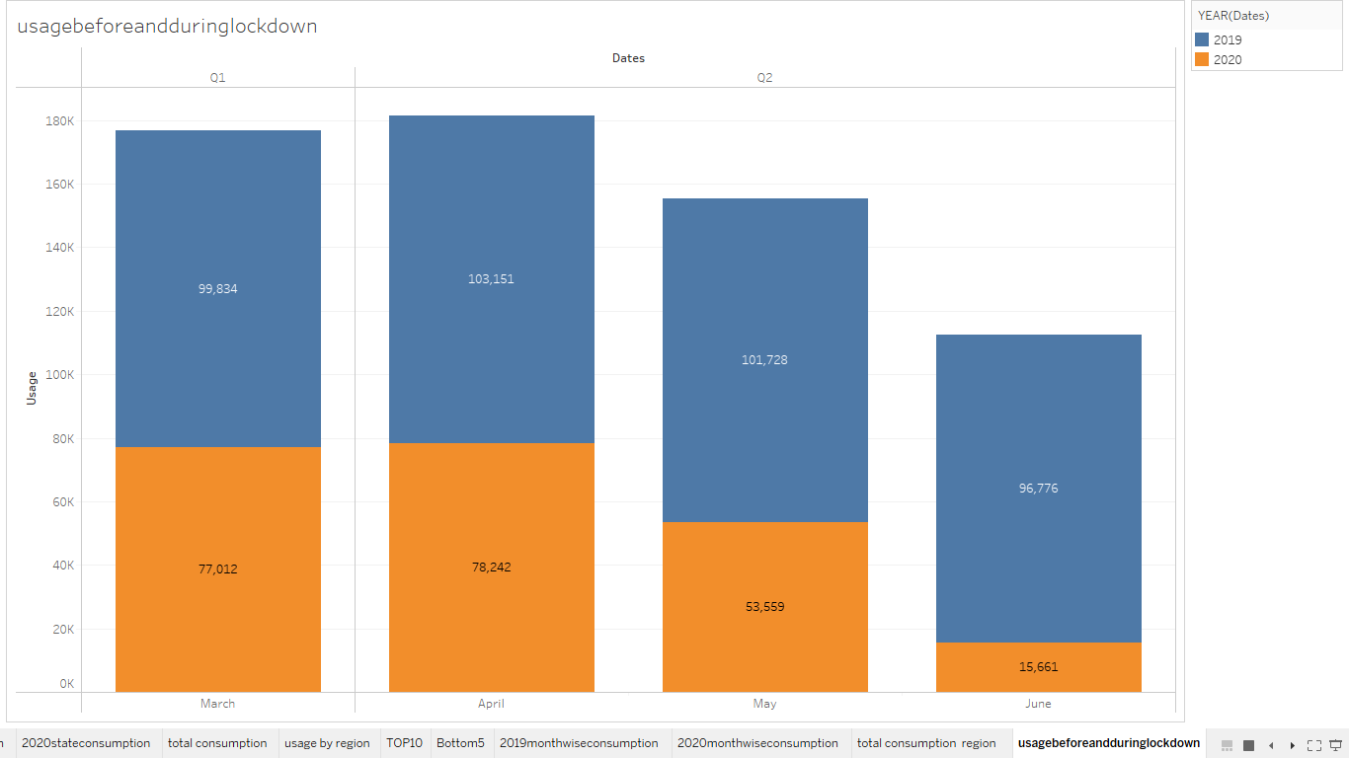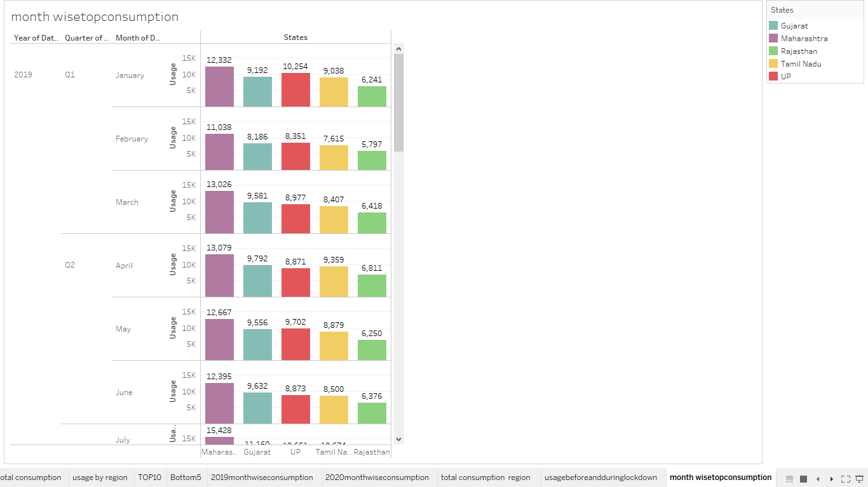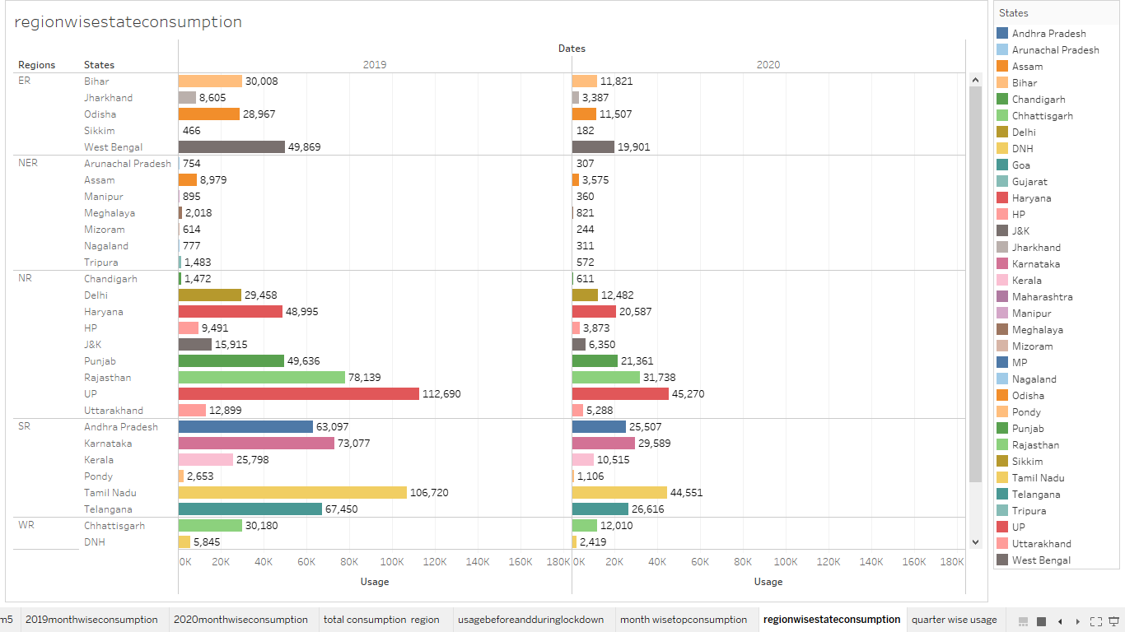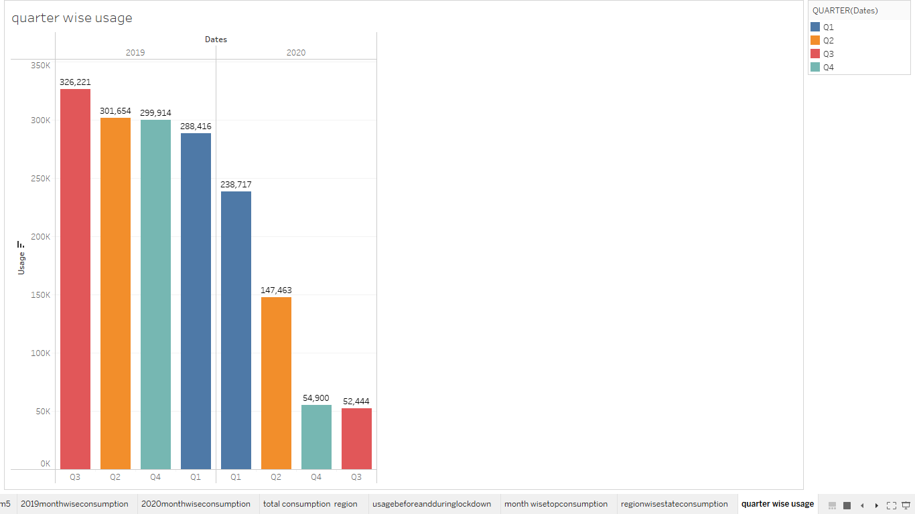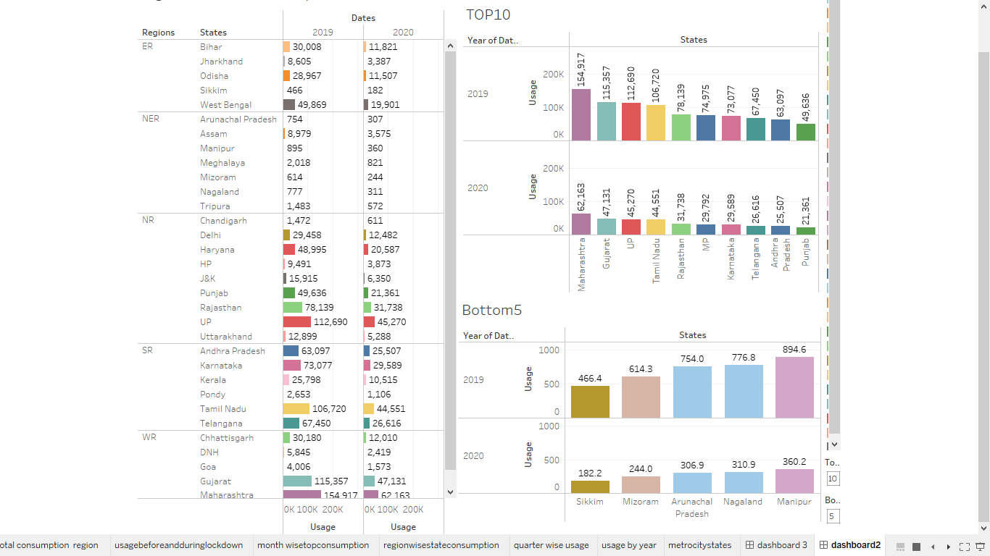

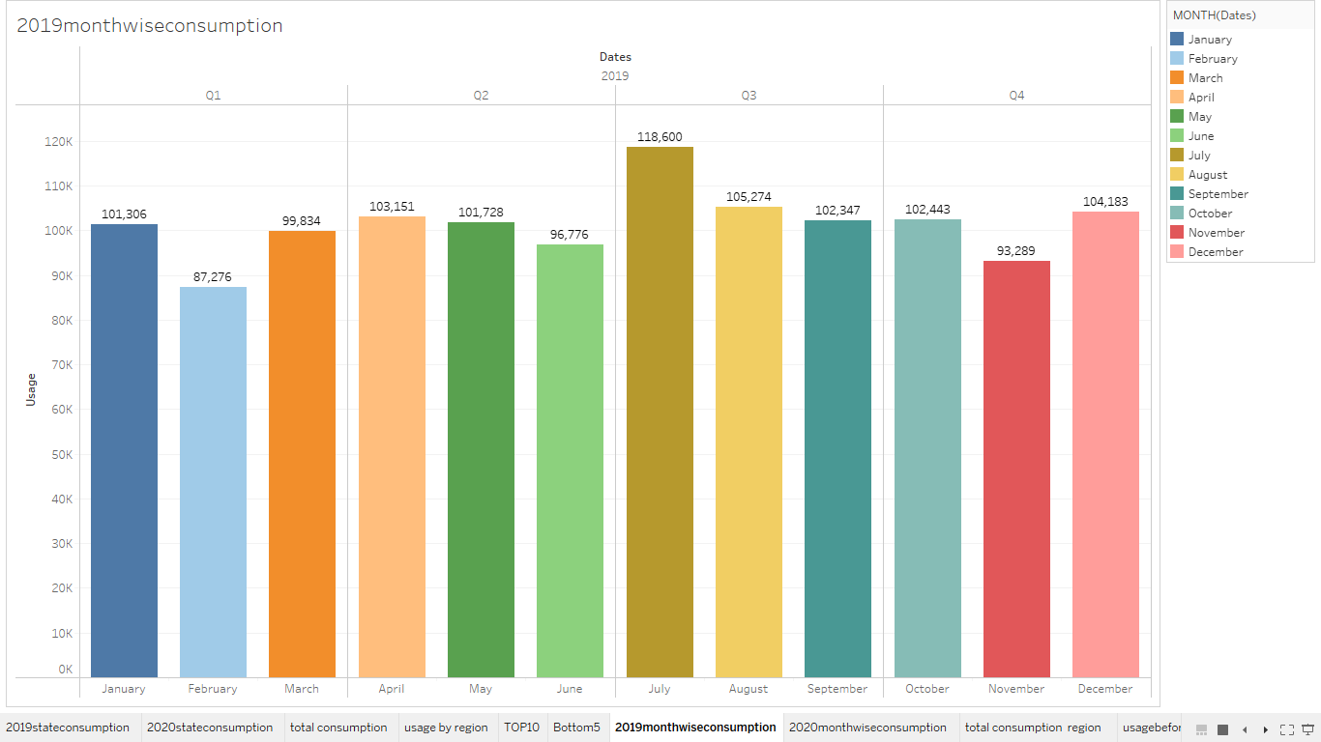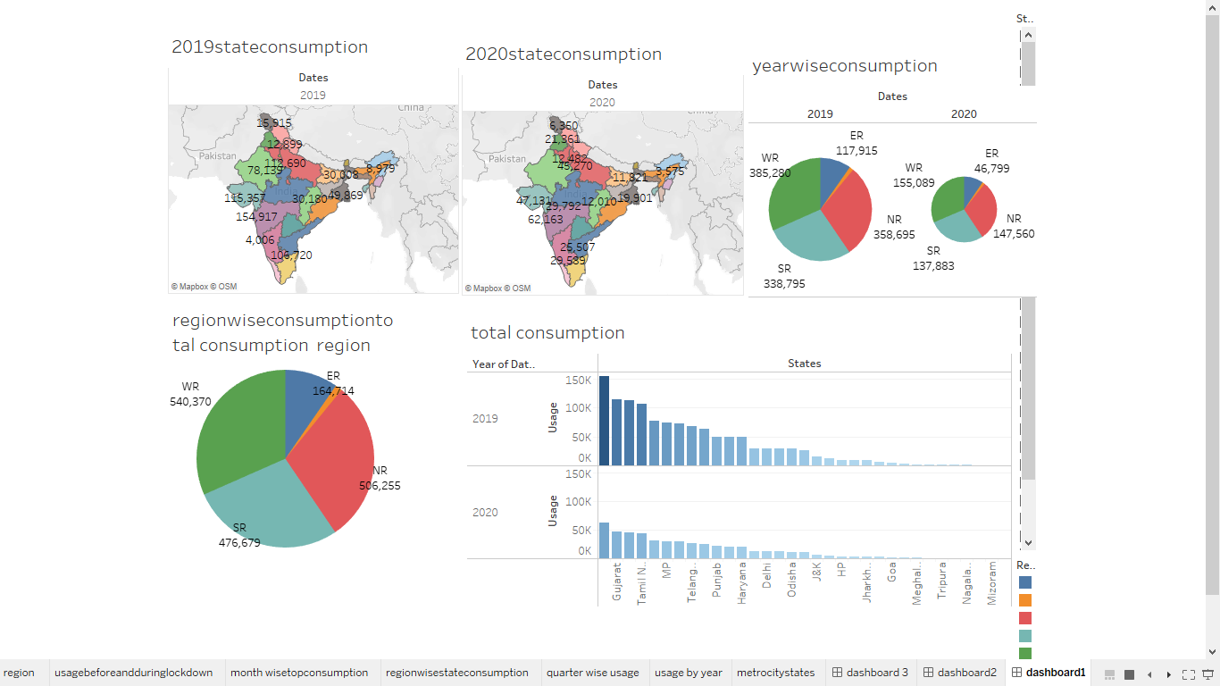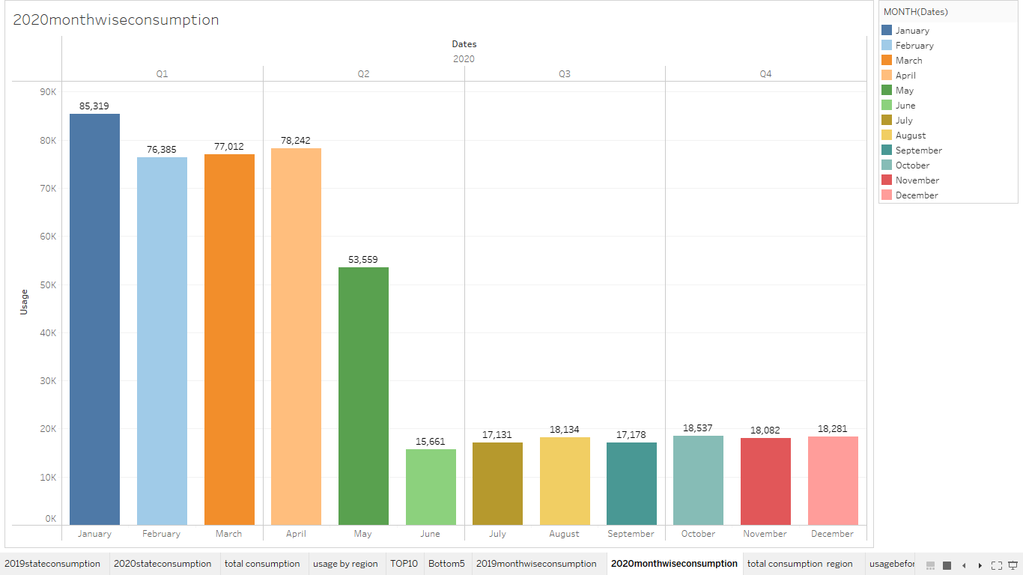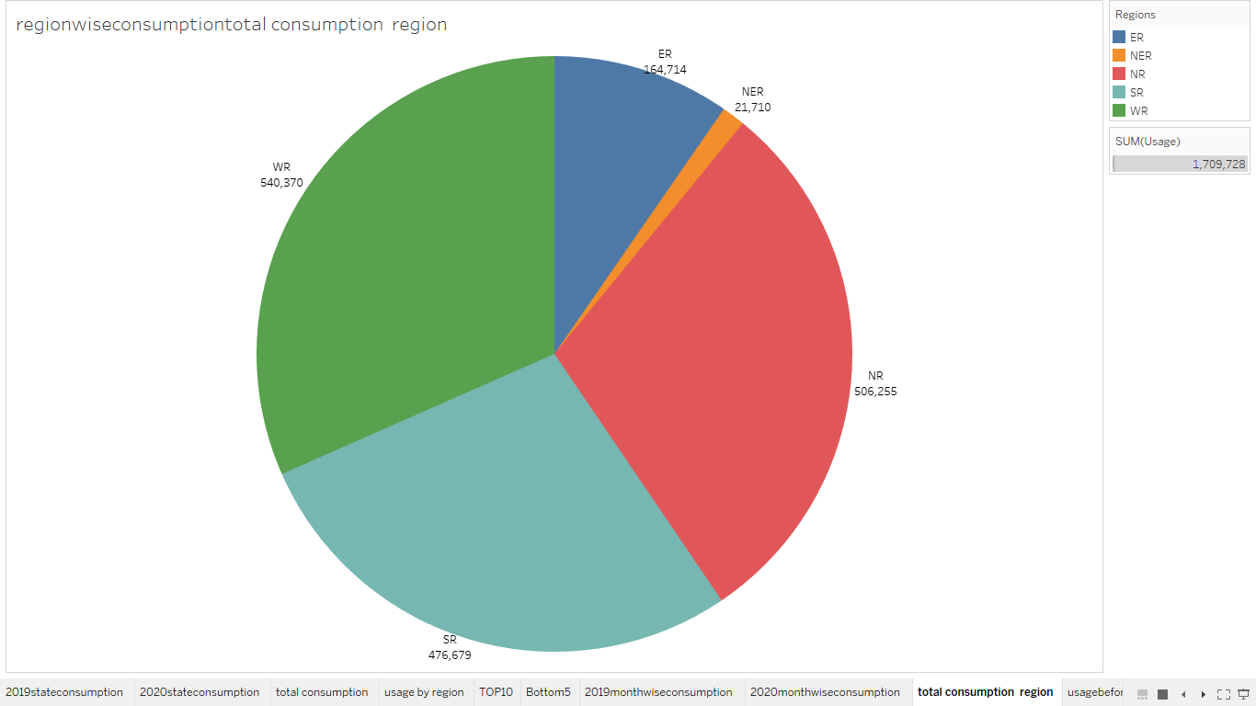

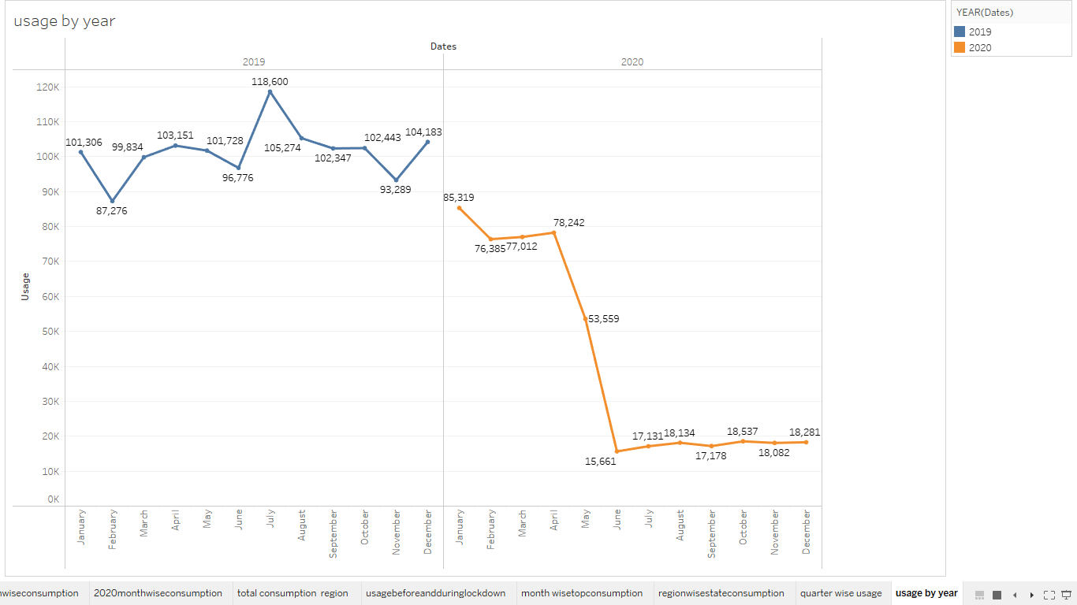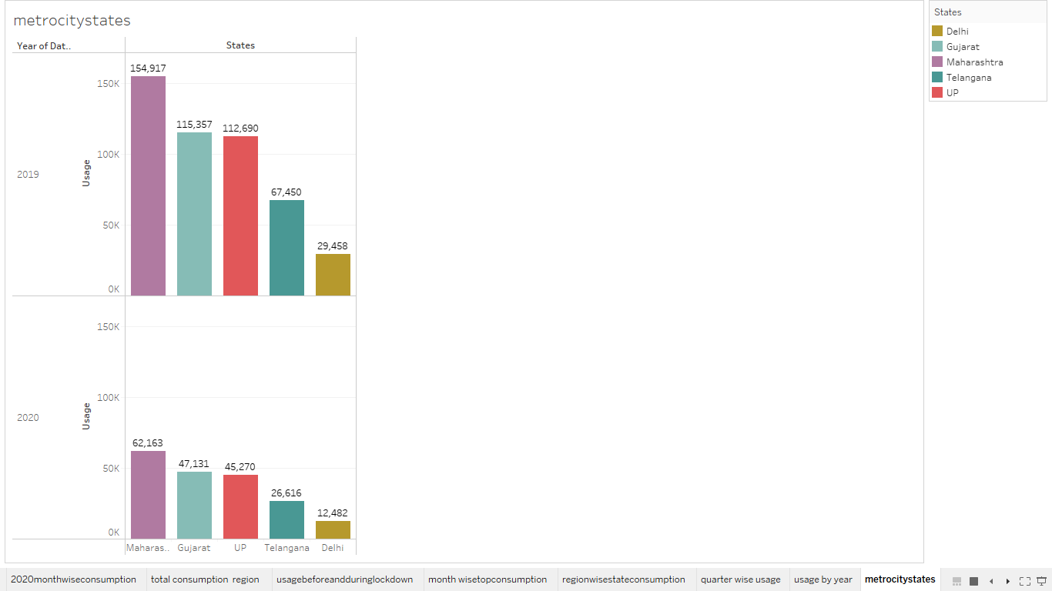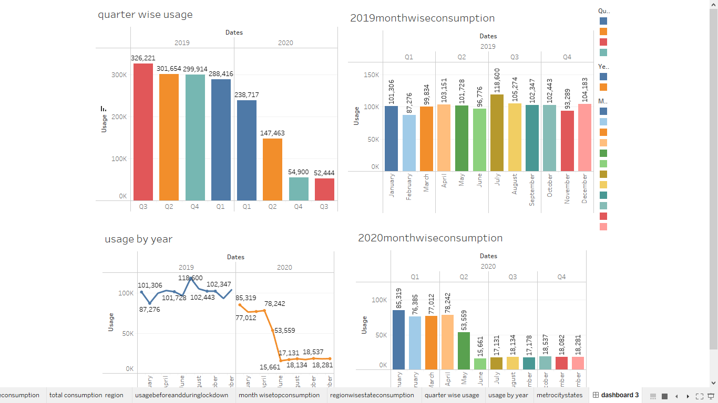

4.ADVANTAGES OF ELECTRICITY:

* It is a clean, safe, cheap and convenient source of energy
* Lower maintenance cost
* More efficient
* No tailpipe emission
* We all know that it can be set up in many sizes
* It doesn't require as many employees
* Reduces greenhouse emission
* Makes barely any pollution compared to other ways of creating or generating electricity
* Relatively low maintenance cost
* Hydroelectric station is inexpensive to operate
* Hydroelectricity produces no gas emissions or waste
* A station can operate and run for long periods of time
* It is renewable

DISADVANTAGES OF ELECTRICITY:

* More expensive than gasoline
* Loss of fish species
* Sometimes messes up wildlife
* Dependent on precipitation
* More power plants and more pollution
* Damming can cause loss of land suitable for agriculture as well as recreation
* Cost for construction
* Change in river or stream quality
* An electric vehicle is not completely emission free
* In electricity, there are a limited number of feasible sites for a large number of dams
* Drought can affect power production
* Hydroelectric natural seasonal changes in river and ecosystems can be destroyed

IMPORTANCE Of ELECTRICITY IN DAILY LIFE:

1. Our regular use of electricity is a secondary source of energy.

2.Electricity is generated by converting fundamental and natural energy sources such as coal, natural gas, nuclear energy, solar energy, and wind energy into electrical energy, which has become critical in enabling human lives and accomplishing the nation's economic revival.

3.The discovery of electric energy resulted in the design and manufacture of gadgets that changed their age, and scientific breakthroughs have contributed to the development and advancement of electricity use.

4.Thomas **Edison, for example, developed** the light bulb, which is considered one of the most important innovations in human history.

5.APPLICATION OF ELECTRICITY:

* COMMERCIAL:

The factory employs heavy machinery that is always powered by electricity to manufacture various materials. Even giant-sized magnets require power to keep them charged in order to lift heavy metals.

* ENGINEERING:

Buildings and structures for people's convenience necessitate the use of energy at every stage. Building buildings, installing gates and windows, and welding materials all require the use of current energy to power the machinery.

* ENTERTAINMENT:

The MP3 player, portable battery-powered radio, and memory stick are all regarded as essential aspects of our daily lives; all rely on electricity to work, whether linked to the mains or a power source such as a battery.

* FUELS:

Electrical energy is a type of renewable energy that can be produced using the majority of the natural resources that are accessible to us. Things that used to operate on fossil fuels, such as vehicles and motorcycles, are now designed to run on electricity (such as solar-powered), which will be more convenient in the future.

* HEALTHCARE:

1. Surgical procedures
2. During a patient's procedure, doctors require a bright light.
3. The surgery might be deadly if there is no electricity.

* HOUSEHOLD:

Electricity powers everything from a toaster to a refrigerator, microwave, washing machine, dishwasher, electrical chimney, and a plethora of other equipment designed to make daily life easier.

* OFFICE:

We go to work in places where almost everything is powered by electricity. Electricity is required for the lights, lifts, air conditioning, coffee machine, ID card reader, biometric scanners, and everything else.

* OUTDOORS:

The streetlights on the road require power to work, while pools in colder climates require electricity to heat the water. The lawnmower, which is used to cut grass, is powered by electricity. The water sprinkler on the lawn is also powered by electricity.

* SPACE:

Satellites and probes launched from Earth for space exploration are powered by electricity. Electricity is created via a generator or is battery-powered. Without the use of electricity, the Apollo mission to place humans on the moon would not have been feasible.

* TRANSPORT AND COMMUNICATION:

Only electricity makes it feasible to travel to distant locations or communicate with people in other parts of the world. A power outage while flying might be hazardous.

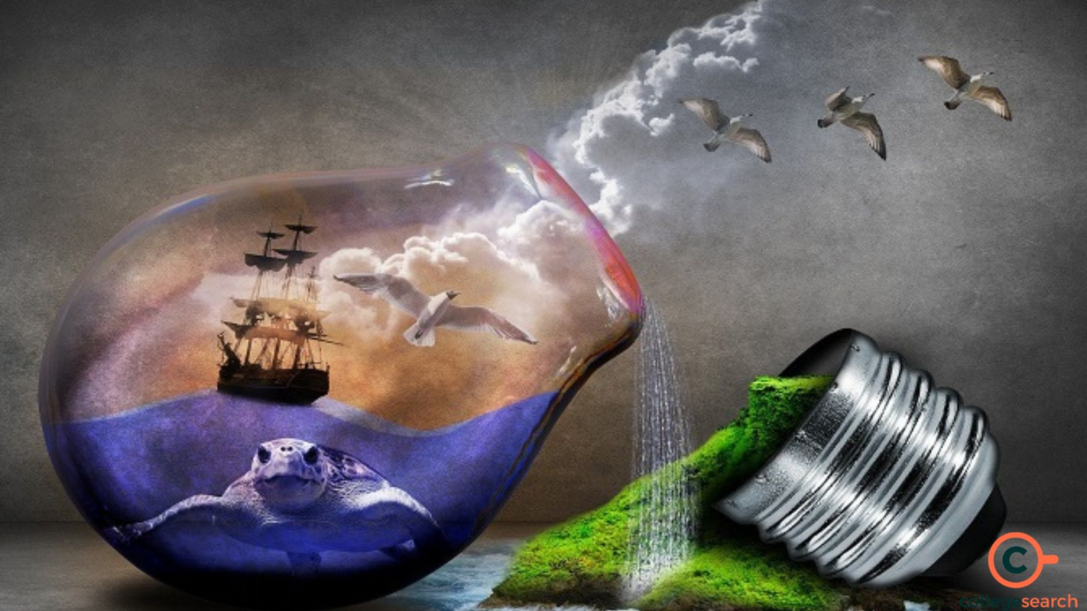

6.CONCLUSION:

This study gives a detailed view of electricity consumption disaggregated by several consumer categories. It aims to provide a holistic as well as a comparative investigation based on socio-economic and technological characteristics. From this paper we came across the consumption of electric energy from 2019 to 2020. Through this we plotted many graphs to understand the electricity consumption in region wise, year wise, state wise, month wise and used many ways. The graph we drawn are using tableau.

7.FUTRUE SCOPE:

In the Stated Policies Scenario, global electricity demand grows at 2.1% per year to 2040, twice the rate of primary energy demand. This raises electricity's share in total final energy consumption from 19% in 2018 to 24% in 2040.

The Indian power sector is forecasted to attract investments worth $128.24-135.37 Bn between FY19-23. The future of the sector looks bright since by 2026-27 the country's power generation installed capacity will close to 620 GW, of which 38 % will be from coal and 44% from renewable energy sources.

We can generate eletricity in the furure may be in the following methods

* Nuclear Energy.
* Hydroelectric Energy. ...
* Wind Energy. ...
* Biomass Energy. ...
* Geothermal Energy. ...
* Solar Energy. ...
* Wave Energy. Wave energy is a type of energy that uses the movement of the ocean's waves to generate electricity. …

The ever-expanding industrialization and urbanization will primarily drive the energy demand that is forecasted to reach 405 Gigawatts of renewable energy capacity by 2030. What is the scope and future of renewable energy resources in India?

India is aiming to attain 175 GW of renewable energy which would consist of 100 GW from solar energy, 10 GW from bio-power, 60 GW from wind power, and 5 GW from small hydropower plants by the year 2022. Investors have promised to achieve more than 270 GW, which is significantly above the ambitious targets.